Fork

What is Fork?
# Source: AI Source: Provided by: [Data Path: Persons Table -> ID Column: 1, Name_En Column: Motasem Essam] -> From: [ChatGPT] on [2/15/2026]
In version control systems (VCS) like Git, a fork is when you create your own personal copy of someone else’s repository on a remote platform (like GitHub, GitLab, or Bitbucket).
Unlike cloning, which makes a copy on your local computer, a fork lives on the remote server under your account. It’s mainly used for collaborating on projects you don’t have direct write access to.

Key Points About Forking
# Source: AI Source: Provided by: [Data Path: Persons Table -> ID Column: 1, Name_En Column: Motasem Essam] -> From: [ChatGPT] on [2/15/2026]
- Remote copy: A fork is a copy of the repository on your own GitHub (or other platform) account.
- Independent development: You can make changes freely in your fork without affecting the original repository.
- Contributing back: You can propose your changes to the original repo by creating a pull request.
Sure! Let’s go step by step with examples and explanations for each key point about a fork:

1. Remote copy
# Source: AI Source: Provided by: [Data Path: Persons Table -> ID Column: 1, Name_En Column: Motasem Essam] -> From: [ChatGPT] on [2/15/2026]
What it means: A fork is a copy of someone else’s repository on your own account, stored on the remote server (GitHub, GitLab, etc.).
Example:
- The repository OriginalUser/WeatherApp exists on GitHub.
- You fork it, creating YourUser/WeatherApp on your GitHub account.
Explanation:
- You now have a separate copy on GitHub that you fully control.
- Changes you make in your fork do not affect the original repo (OriginalUser/WeatherApp).

2. Independent development
# Source: AI Source: Provided by: [Data Path: Persons Table -> ID Column: 1, Name_En Column: Motasem Essam] -> From: [ChatGPT] on [2/15/2026]
What it means: You can make changes freely in your fork without worrying about breaking the original project.
Example:
- You forked OriginalUser/WeatherApp and cloned it locally:
git clone https://github.com/YourUser/WeatherApp.git
git checkout -b add-rain-alert
- You add a new feature to send alerts when it’s going to rain and commit the changes.
git commit -am "Add rain alert feature"
git push origin add-rain-alert
Explanation:
- All changes are in your fork and branch.
- The original repository continues unchanged, so you can experiment safely.

3. Contributing back
# Source: AI Source: Provided by: [Data Path: Persons Table -> ID Column: 1, Name_En Column: Motasem Essam] -> From: [ChatGPT] on [2/15/2026]
What it means: After making improvements in your fork, you can propose that the original repository include your changes.
Example:
- On GitHub, you create a pull request from your branch add-rain-alert in YourUser/WeatherApp to OriginalUser/WeatherApp.
- The maintainers of the original repo review your code and, if approved, merge it into the main project.
Explanation:
- Forking allows you to contribute to projects you don’t own.
- The pull request is a way to submit your work back safely, without directly pushing to the original repo.

💡 Analogy:
# Source: AI Source: Provided by: [Data Path: Persons Table -> ID Column: 1, Name_En Column: Motasem Essam] -> From: [ChatGPT] on [2/15/2026]
- Remote copy: You get your own copy of the book from the library.
- Independent development: You freely write notes, highlight sections, or add chapters in your copy.
- Contributing back: You submit your suggestions to the library for possible inclusion in the original book.

If you want, I can also make a simple diagram showing “Fork → Clone → Branch → Pull Request”, which makes all three points extremely easy to visualize.
Do you want me to create that diagram?

Why Use a Fork?

1️⃣ Contribute to Open Source
# Source: AI Source: Provided by: [Data Path: Persons Table -> ID Column: 1, Name_En Column: Motasem Essam] -> From: [ChatGPT] on [2/15/2026]
If you don’t have write access to a repository, you:
- Fork it
- Make changes in your copy
- Submit a Pull Request

2️⃣ Experiment Safely
# Source: AI Source: Provided by: [Data Path: Persons Table -> ID Column: 1, Name_En Column: Motasem Essam] -> From: [ChatGPT] on [2/15/2026]
You can:
- Add features
- Fix bugs
- Break things 😄
Without impacting the original project.

Fork vs Clone
# Source: AI Source: Provided by: [Data Path: Persons Table -> ID Column: 1, Name_En Column: Motasem Essam] -> From: [ChatGPT] on [2/15/2026]
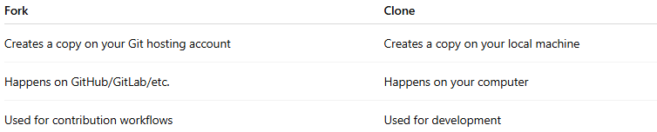
Fork | Clone
Creates a copy on your Git hosting account | Creates a copy on your local machine
Happens on GitHub/GitLab/etc. | Happens on your computer
Used for contribution workflows | Used for development

Example
# Source: AI Source: Provided by: [Data Path: Persons Table -> ID Column: 1, Name_En Column: Motasem Essam] -> From: [ChatGPT] on [2/15/2026]
- There’s an open-source project called AwesomeApp owned by OriginalUser.
- You want to add a new feature but don’t have write access.
Step 1: Fork the repository on GitHub
- GitHub creates a copy of OriginalUser/AwesomeApp under your account, e.g., YourUser/AwesomeApp.
Step 2: Clone your fork locally
git clone https://github.com/YourUser/AwesomeApp.git
Step 3: Make changes and push to your fork
git checkout -b add-new-feature
git commit -m "Add a new feature"
git push origin add-new-feature
Step 4: Create a pull request
- On GitHub, you submit a pull request from your fork to the original repository so your changes can be merged.

Real-World Example
# Source: AI Source: Provided by: [Data Path: Persons Table -> ID Column: 1, Name_En Column: Motasem Essam] -> From: [ChatGPT] on [2/15/2026]
Let’s say you want to contribute to a popular open-source project:
- You fork it
- You fix a bug
- You push changes to your fork
- You create a Pull Request
- The project owner reviews and merges your changes

Difference Between Fork and Clone
# Source: AI Source: Provided by: [Data Path: Persons Table -> ID Column: 1, Name_En Column: Motasem Essam] -> From: [ChatGPT] on [2/15/2026]
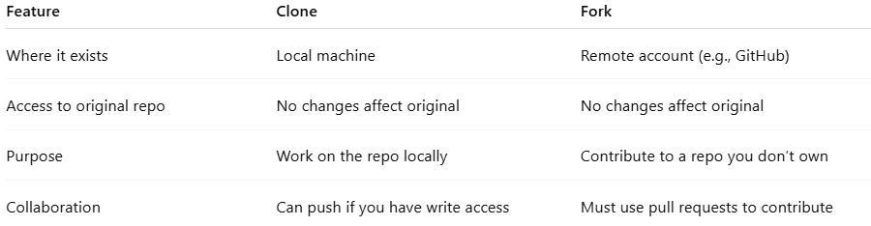
Feature | Clone | Fork
Where it exists | Local machine | Remote account (e.g., GitHub)
Access to original repo | No changes affect original | No changes affect original
Purpose | Work on the repo locally | Contribute to a repo you don’t own
Collaboration | Can push if you have write access | Must use pull requests to contribute

💡 Analogy:
# Source: AI Source: Provided by: [Data Path: Persons Table -> ID Column: 1, Name_En Column: Motasem Essam] -> From: [ChatGPT] on [2/15/2026]
- Clone: Like photocopying a book to read and annotate at home.
- Fork: Like requesting your own copy of the book from the library so you can make changes, then submit suggestions back to the library.

Quick Summary
# Source: AI Source: Provided by: [Data Path: Persons Table -> ID Column: 1, Name_En Column: Motasem Essam] -> From: [ChatGPT] on [2/15/2026]
- 🔹 Fork = remote copy under your account
- 🔹 Clone = local copy on your machine
- 🔹 Used mainly for contributing to projects you don’t own

